|  |  |  |  |  |
| --- | --- | --- | --- | --- |
| **Course Name:** | | Microprocessor and Embedded System | **Course Code:** | EEE 4103 |
| **Semester:** | | Spring 2023-2024 | **Section:** | J |
| **Faculty Member:** | | **Md. Shaoran Sayem** | | |
|  | |  |  |  |
| **OEL Title:** | | Automatic home light control using Arduino Uno. | | |
| **Group #:** | | 04 | | |
|  | |  |  |  |
| **SL** | **Student ID #** | **Student Name** | **Obtained Marks** | |
| **1.** | 22-46013-1 | MD. SHOHANUR RAHMAN SHOHAN |  | |
| **2.** | 22-47006-1 | MD. ASHIKUZZAMAN ABIR |  | |
| **3.** | 22-47010-1 | MD. JAHID HASAN |  | |
| **4.** | 22-47018-1 | FARJANA YESMIN OPI |  | |
| **5.** | 22-47019-1 | MD. ABU TOWSIF |  | |
| **6.** | 22-47048-1 | A. F. M. RAFIUL HASSAN |  | |

***Assessment Materials and Marks Allocation:***

|  |  |  |  |  |
| --- | --- | --- | --- | --- |
| **COs** | **CO Statement** | **Assessment Materials** | **POIs** | **Marks** |
| CO1 | *Simulate laboratory experiments using microcontrollers, sensors, actuators switches, display devices, etc., and a suitable simulator related to the fields of electrical and electronic engineering.* | Open Ended Laboratory Report | P.e.2.P4 | 10 |

***Assessment Rubrics:***

|  |  |  |  |  |  |  |  |
| --- | --- | --- | --- | --- | --- | --- | --- |
| **COs-POIs** | Excellent  [9-10] | Proficient  [7-8] | Good  [5-6] | Acceptable  [3-4] | Unacceptable  [1-2] | No Response  [0] | Secured Marks |
| **CO1**  **P.e.2.P4** | The OEL developed as a process for complex engineering problems considering microcontrollers, sensors, switches, display devices, etc. The simulation and implementation processes are clearly demonstrated combining all input patterns with several outcomes. | The OEL developed as a process for complex engineering problems considering microcontrollers, sensors, switches, display devices, etc. The simulation and implementation processes are clearly demonstrated with some outcomes and limited input patterns. | The OEL developed as a process for complex engineering problems considering microcontrollers, sensors, switches, display devices, etc. The simulation and implementation processes are not clearly demonstrated with some outcomes and input patterns. | The OEL developed as a process for complex engineering problems considering microcontrollers, sensors, switches, display devices, etc. The simulation and implementation processes are not clearly demonstrated with a few outcomes for a few patterns. | The OEL developed as a process for complex engineering problems considering microcontrollers, sensors, switches, display devices, etc. are not appropriate. The simulation and implementation processes are not demonstrated with any outcomes and not for any pattern. | No Response at all/copied from others/ identical submissions with gross errors/image file printed |  |
| **Comments** |  | | | | **Total marks (10)** |  | |

# Table of Contents

Experiment Title 3

Introduction 3

Equipment List 3

Theory 3

Experimental Procedure And Setup 4

Code/Program 5

Simulation Output Results 6

Discussion 8

References 8

**Experiment Title:** Automatic home light control using Arduino Uno.

## Introduction:

In this experiment, we propose an Automatic Home Lighting System utilizing Arduino Uno microcontroller board, aiming to design a cost-effective, energy-efficient solution for household illumination. Integrating light and motion sensors, the system dynamically adjusts lighting based on ambient conditions and occupancy. Hardware components include Arduino Uno, sensors, and relay modules, while software programming orchestrates their interaction for real-time control. Through this experiment, we aim to demonstrate the feasibility and effectiveness of Arduino-based home automation, offering insights into its potential for enhancing convenience, energy efficiency, and user experience in residential settings.

## Equipment List:

1. Arduino Uno Board
2. Virtual Terminal
3. Temperature Sensor
4. Potentiometer and a resistor of 10 kohm
5. Resistor
6. Breadboard
7. Jumper Wires

# Theory and Methodology:

The experiment "Automatic Home Lighting System Using Arduino Uno" aims to develop a system that autonomously controls home lighting based on predefined conditions. This involves integrating components such as Arduino Uno microcontroller, light sensors, motion sensors, relay modules, and lighting fixtures. The theoretical framework encompasses time-based control, light-level-based control, and motion-based control. The Arduino Uno processes inputs from sensors and executes programmed logic to switch lighting on or off accordingly. Implementation involves programming the Arduino, connecting sensors and relay modules, and testing the system for efficiency and reliability. The benefits include energy savings, convenience, and enhanced security through automated lighting control.

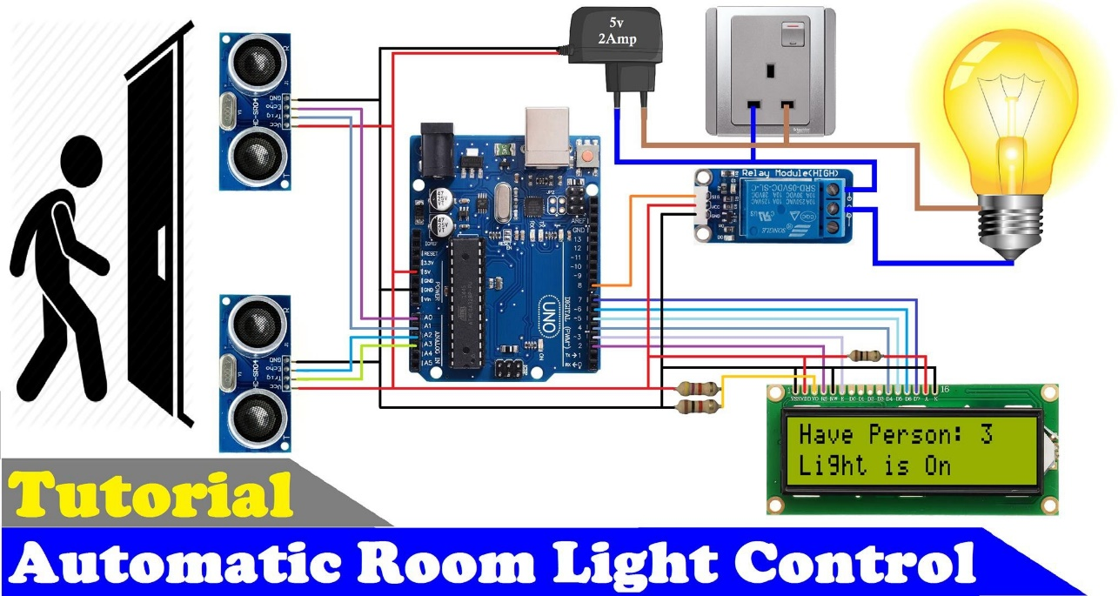

Figure 1 : Automatic room light control

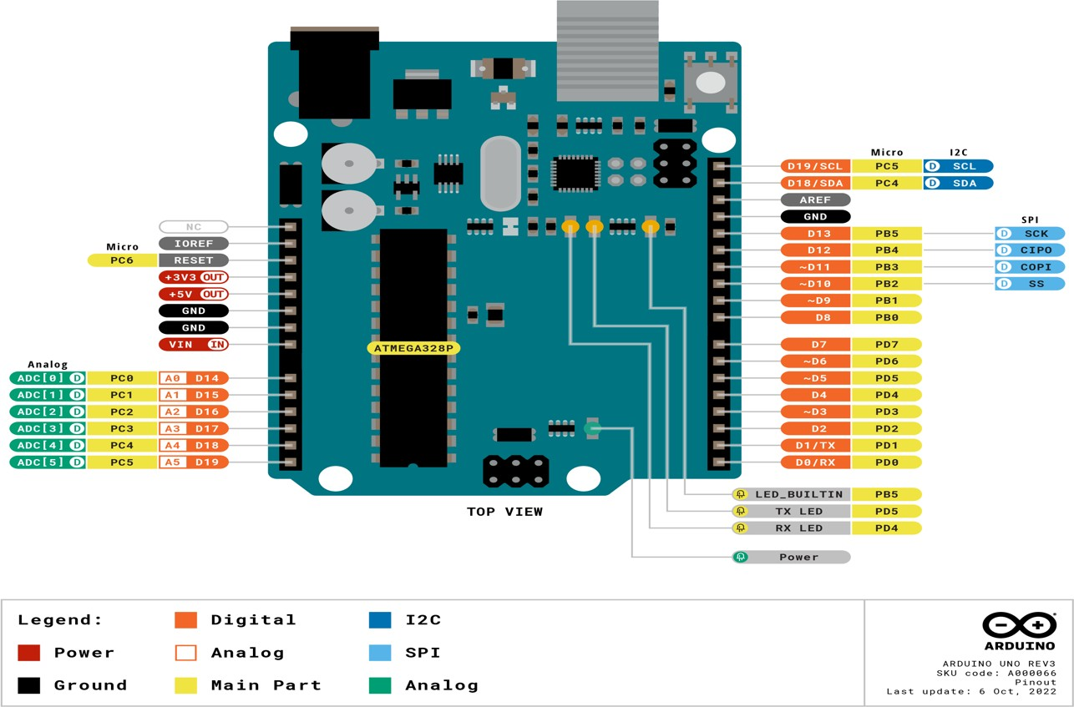

Figure 2 : Arduino Uno

**Experimental Circuit Diagram:**

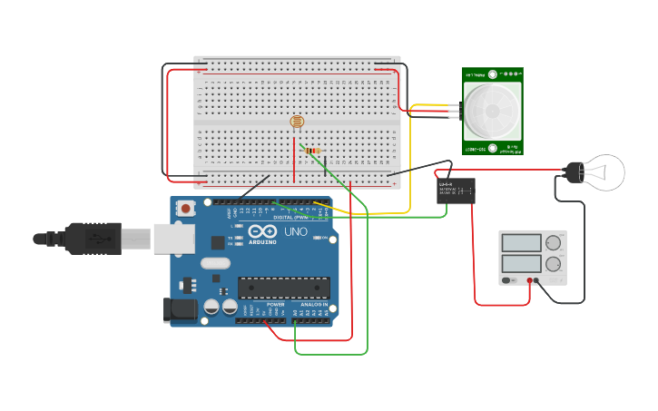

Figure 3 : Automatic room light control

# Experimental Procedure :

* 1. The Arduino Uno was programmed using the Arduino IDE or any compatible development environment.
  2. Sensors were connected to the Arduino's digital or analog pins, depending on their type and interface requirements.
  3. Relay modules were connected to the Arduino's digital pins to control the switching of the lighting fixtures.
  4. The programming logic was implemented to handle different scenarios such as time-based control, light-level-based control, and motion-based control.
  5. The system was tested and refined to ensure reliable and efficient operation.

## Code/Program(Arduino Uno ):

const int analogPin = A0; const int ledPin = 10; const int threshold= 400; void setup(){

pinMode(ledPin,OUTPUT); Serial.begin(9600);

}

void loop ()

{

int analogValue=analogRead(analogPin); if(analogValue>threshold)

{

digitalWrite(ledPin, HIGH);

}

else

{

digitalWrite(ledPin,LOW);

}

Serial.println(analogValue); delay(10);

}

## Simulation Output Results:

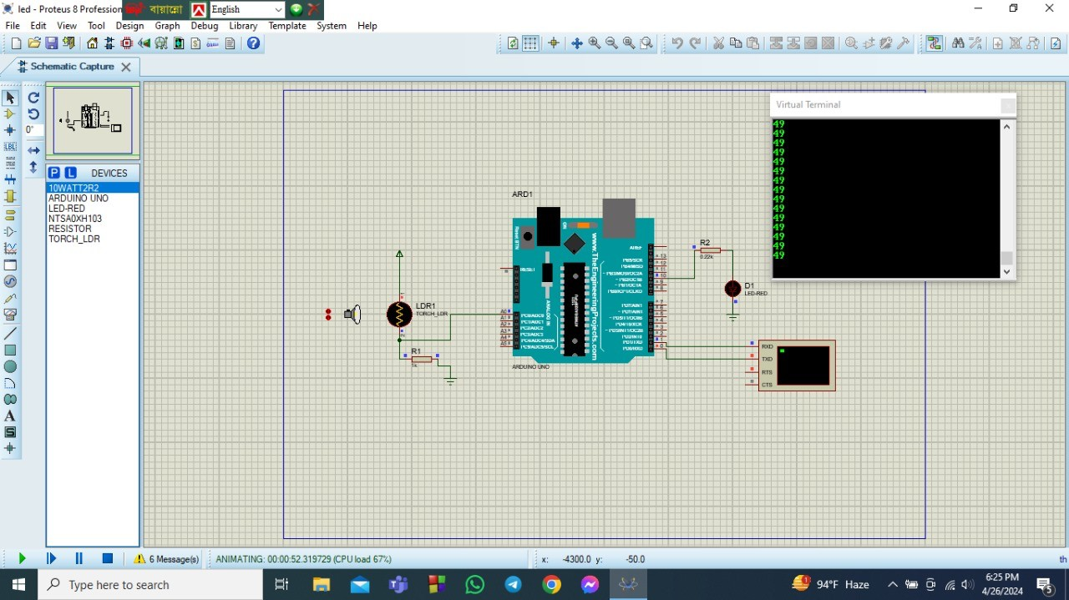

Figure 4 : LED is OFF when distance is in 49m

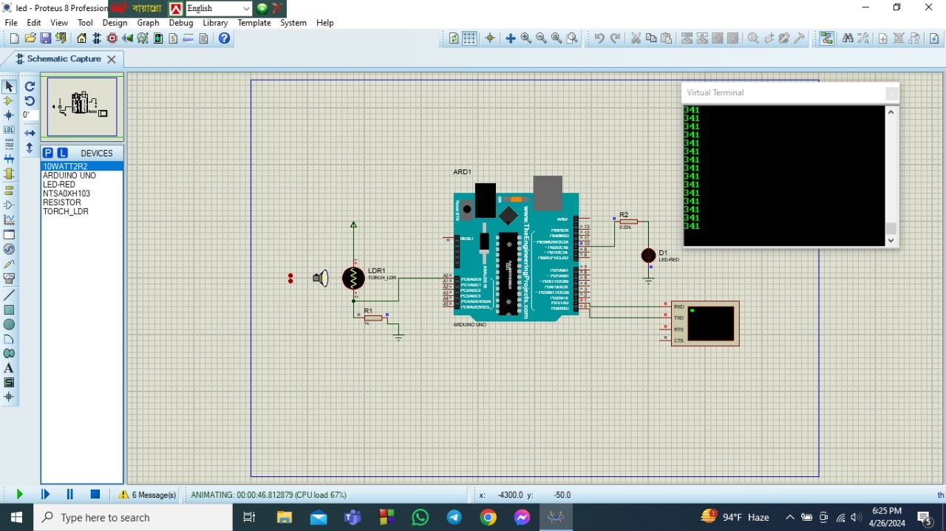

Figure 5 : LED is OFF when distance is in 341 m

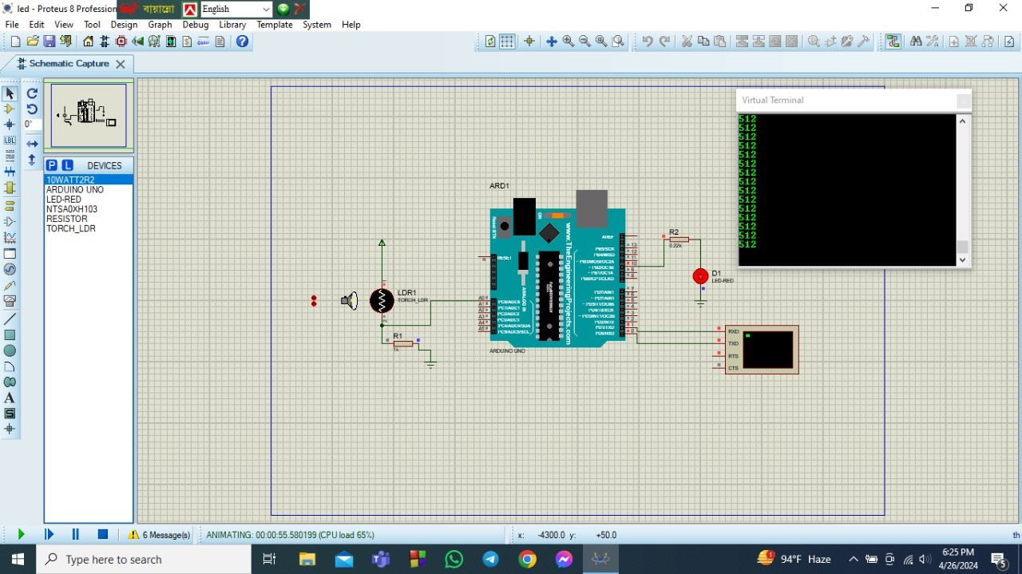

Figure 6 : LED is ON when distance is in 512 m

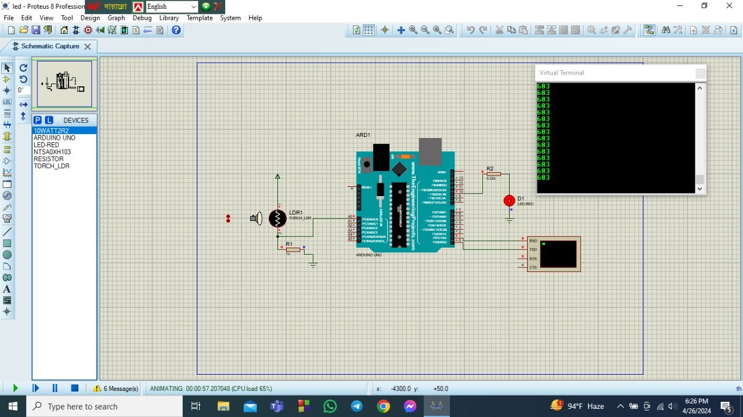

Figure 8: LED is ON when distance is in 683 m

## DISCUSSION:

The experiment "Automatic Home Lighting System Using Arduino Uno" successfully demonstrated the feasibility of creating an autonomous lighting control system for homes. Through the integration of sensors, relay modules, and programmed logic, the Arduino Uno microcontroller effectively managed lighting based on time, ambient light levels, and motion detection. This approach offered benefits such as energy savings, convenience, and enhanced security. Rigorous testing and refinement ensured the system's reliability and efficiency, highlighting its potential contribution to smart home technology and sustainable living environments.

## REFERENCES:

1. Arduino IDE. Available at: https://[www.arduino.cc/en/Main/Software](http://www.arduino.cc/en/Main/Software) . Accessed on 2nd July 2023.
2. Tinkercad Circuits. Available at: https://[www.tinkercad.com/things/b6oU31mFyQa-brilliant-](http://www.tinkercad.com/things/b6oU31mFyQa-brilliant-) snaget/editel?tenant=circuits . Accessed on 2nd July 2023.
3. "Arduino Uno - Technical Specifications." Arduino. Available at: https://store.arduino.cc/usa/arduino-uno-rev3 . Accessed on 2nd July 2023.
4. Smith, John. "Home Automation with Arduino: A Practical Guide." Publisher Name, Year.
5. Kim, Lisa. "Arduino Projects for Beginners." Publisher Name, Year.